FHTC Household Tap Connection

User Manual



M.P. STATE ELECTRONICS DEVELOPMENT CORPORATION LTD.
State IT Centre, 47-A, Arera Hills, Bhopal-462011 (M.P.)
www.mpsedc.mp.gov.in

Table of Contents
FHTC Household Tap Connection 1
User Manual 1
1. Introduction 2
2. Objective of FHTC Module 2
3. User Roles 2
4. System Access 2
5. Field Engineer – Household Survey & Tap Installation 2
6. Validation Rules 3
7. Contractor Workflow 3
8. GM Approval Workflow 3
9. Status Lifecycle 3
10. Reports 3
11. Screens of FHTC 3
12. Error Handling 4
13. Security & Audit 4
14. FAQs 4
15. Conclusion 4

1. Introduction
This user manual describes the end-to-end process of the Functional Household Tap Connection (FHTC) module under Jal Jeevan Mission. The module facilitates household survey, tap installation, verification, approval, and reporting through web and mobile applications.

2. Objective of FHTC Module
• Capture household survey details
• Track tap connection installation status
• Enable GM and Contractor approvals
• Ensure geo-tagged verification
• Maintain transparent and auditable records

3. User Roles
• Field Engineer (FE)
• Contractor
• General Manager (GM)
• System Administrator

4. System Access
Users can access the FHTC system via:
• Web Portal (GM / Contractor)
• Mobile Application (Field Engineer)
Login requires valid username and password provided by the department.

5. Field Engineer – Household Survey & Tap Installation
Step 1: Login to mobile application
Step 2: Select village and household
Step 3: Conduct household survey
Step 4: Capture GPS location and photos
Step 5: Install tap connection
Step 6: Submit readings and evidence

6. Validation Rules
• GPS must be within 50 meters of household location
• Mandatory photo upload
• All required fields must be filled
• Duplicate household validation using Samagra Family ID

7. Contractor Workflow
• Login to web portal
• View assigned households
• Track installation status
• View rejection reasons
• Generate contractor reports

8. GM Approval Workflow
• Login to GM dashboard
• Review household connection details
• Verify photos and readings
• Approve or reject tap connection
• Forward verified connections for reporting

9. Status Lifecycle
• Draft
• Submitted
• Pending Verification
• Approved
• Rejected
• Connected

10. Reports
• GM Reports (Village-wise, Scheme-wise)
• Contractor Reports
• Pending at PIU Report
• Aging Reports
• Export to Excel and PDF

11. Screens of FHTC

11.1. GM Login :
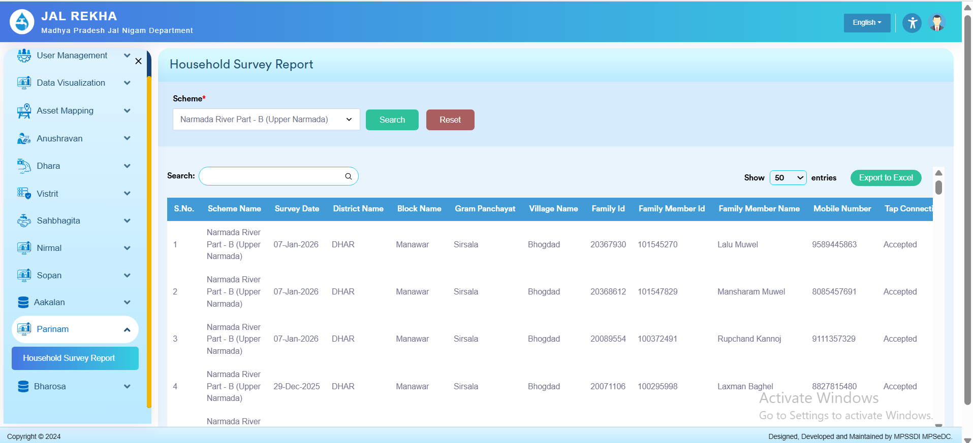

11.2. Contractor Login

11.3. FE Mobile Login

12. Error Handling

• Network failure handling (offline mode for FE)
• Validation error messages displayed on screen
• Re-submission allowed after correction

13. Security & Audit
• Role-based access control
• Audit trail for approvals and rejections
• Secure authentication using JWT

14. FAQs
Q1. What if GPS is not captured?
A. Submission will be blocked until GPS is captured.
Q2. Can rejected connections be re-submitted?
A. Yes, after correcting the issues highlighted.

15. Conclusion
The FHTC module ensures transparent, accurate, and efficient tracking of household tap connections and supports the Jal Jeevan Mission objectives through digital governance.

